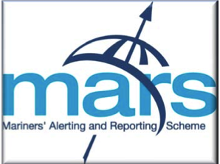
International Mariners' Alerting
and Reporting Scheme Form
Please complete this form and send by email to the Editor at: mars@nautinst.org

MARS is primarily a confidential reporting system run by The Nautical Institute to allow full reporting of accidents (and near misses) without fear of identification or litigation

Reporter's Name, Rank/Occupation

Contact address (Please supply a contact address in case any point requires clarification)

Email:

Factual
Details of the Accident, Incident or Near Miss

Analysis
Results of the investigation

Fatigue Involved?
(if fatigue is suspected give a short summary of the persons work-rest history going back at least 72 hours from the time of the event).

Root Cause and Contributing Factors

Lessons Learned

Risk reduction measures or other actions taken subsequent to investigation

* Photos (please insert below, or send as separate files any photos that help illustrate the report)

