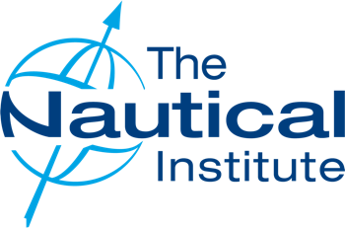

Meet Our Committee

# Gordon Foot MNM FNI

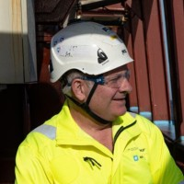Branch Chairman and Hon Secretary

Gordon is a seasoned Offshore Maritime Operations Professional with over 35 years of operational leadership within both the Royal Navy and Merchant Navy. A Chartered Marine Technologist and Chartered Manager, he specialises in the delivery of complex offshore projects across the construction, geoscience, ROV, diving, pipeline, cable, and UXO domains, with significant experience in offshore wind, oil and gas, and environmental operations. Gordon has served extensively as an IOGP Vessel Client Representative, operating in remote and high-risk regions including West Africa and Asia. He brings a strategic yet hands-on approach to project and programme management, underpinned by strong HSSEQ expertise, commercial awareness, and a collaborative leadership style. Adept at leading cross-functional, international teams, he is known for his problem-solving ability, effective communication, and commitment to delivering safe, efficient, and high-quality outcomes for clients worldwide.

# Richard Allan

Vice Chairman

**Captain Richard Allan** is the Harbour Master and Chief Executive of Cattewater Harbour Commissioners, overseeing the Port of Plymouth. He began his tenure with the organisation as Deputy Harbour Master in 2017 and was appointed to his current role in 2020. A Master Mariner with a distinguished seafaring career, Captain Allan is committed to ensuring safe navigation, environmental stewardship, and operational excellence within the harbour. Under his leadership, the port has embraced sustainable practices and community engagement initiatives, reflecting his dedication to both maritime heritage and innovation.​

# Matthew Groves

Treasurer and Young Members Representative

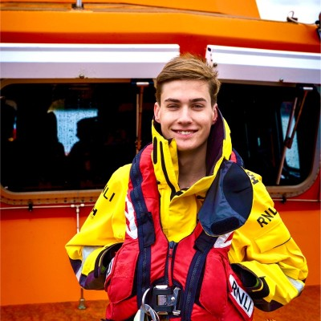Matthew Groves is an emerging maritime professional based in Plymouth, England, studying Navigation and Maritime Science at the University of Plymouth. Alongside his academic studies, he is gaining significant industry experience through his work with Cattewater Harbour Commissioners, supporting pilotage and port operations. Matthew’s maritime career began with a local tour boat operator, progressing into operational roles including pilot boat crewing and maritime security. In addition to his professional commitments, Matthew volunteers as lifeboat crew with Plymouth RNLI, demonstrating a strong personal commitment to maritime safety and community service. Matthew is passionate about professional development and the advancement of safe, sustainable maritime operations. With a growing portfolio of practical experience and academic achievement, he is committed to building a career dedicated to excellence in port management and maritime safety.

# George Lang

Committee Member

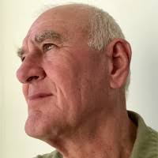George Lang is a seasoned maritime professional with a distinguished career spanning over five decades. From 2010 to 2018, he served at Warsash Maritime Academy, a premier maritime training institution in the United Kingdom. During his tenure, he played a pivotal role in educating and mentoring the next generation of maritime officers, contributing significantly to the academy's reputation for excellence in maritime education.​ Beyond his work at Warsash, George has been an active member of the maritime community. He has been a Fellow of The Nautical Institute since 1972, reflecting his long-standing commitment to advancing maritime safety and professional development. Additionally, he is a member of the Royal Institute of Navigation, underscoring his expertise in navigational practices and standards. George's extensive experience and dedication have made him a respected figure in maritime education and training, with a legacy of fostering excellence and professionalism in the industry.​

# Charles Hattersley

Committee Member

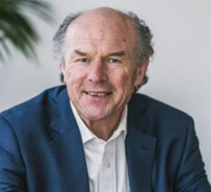Charles Hattersley is a seasoned maritime solicitor and serves as Partner and Head of Marine at Ashfords LLP, a prominent UK law firm with offices in Exeter and Plymouth. With a career spanning several decades, he has established himself as a leading authority in maritime and shipping law, advising clients across the commercial marine sector. His expertise encompasses a wide range of maritime legal matters, including shipbuilding contracts, vessel repair disputes, marine insurance claims, and shipping litigation. He has also contributed to discussions on emerging legal challenges, such as the regulatory implications of unmanned workboats. Charles's in-depth knowledge and practical approach make him a trusted advisor to shipowners, insurers, and maritime businesses. He is known for his ability to navigate complex legal landscapes, ensuring compliance and protecting clients' interests in the dynamic maritime industry.​

# Oliver Chasteauneuf

Committee Member

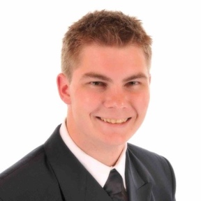Captain Ollie Chasteauneuf is a Master Mariner with extensive experience across the cruise, cargo, and offshore sectors. A graduate of the University of Plymouth, he gained his Master Mariner Unlimited licence in 2016 and has since commanded DP3-class vessels in complex offshore operations. Currently serving as Master and Senior Dynamic Positioning Officer (SDPO) for Dong Fang Offshore, he plays a key role in Taiwan’s offshore wind industry. His career highlights include commanding *Pacific Constructor* during the search for MH370 and the discovery of the Argentine submarine *San Juan*.

# Bob Hone

Committee Member

Captain Robert Hone is a highly experienced Master Mariner with over 30 years of service across passenger, cargo, and cruise vessels, including senior positions as Staff Captain on the QE2 and Chief Officer on the QM2. After a A person in a uniform smiling
distinguished maritime career, Captain Hone transitioned into academia, teaching Navigation and Maritime Science at the University of Plymouth for a decade. During his time at the University, he mentored and trained future maritime professionals, focusing on bridge resource management and the human aspects of ship operations. He has contributed to key publications on maritime safety and navigation, including a chapter on Bridge Resource Management in *Navigation Accidents and their Causes*. Captain Hone has also been actively involved in maritime safety and research initiatives, including the Plymouth University Maritime Cyber-Crime Research Group and the Plymouth Autonomous Sailboat project. He is a Fellow of the Nautical Institute and the Higher Education Academy.

# David Guy

Committee Member

Dave Guy is an experienced Marine Advisor at BP, specialising in the assessment and inspection of the company’s marine operations. Based in Fowey, Cornwall, he applies his extensive knowledge to ensure the safety, compliance, and efficiency of BP’s maritime activities. With a strong foundation in maritime operations, Dave’s career is supported by his education at Warsash Maritime Academy. His commitment to safety and operational excellence in the maritime industry is evident in his ongoing work with BP.

# Peter Hinchliffe

Committee Member

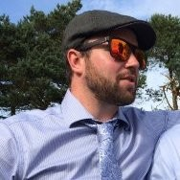Peter Hinchcliffe is an experienced Cables Director with a strong background in the maritime and offshore industries. In his current role, he leads the strategy and execution of subsea cable projects, overseeing the installation and maintenance of critical infrastructure for offshore wind farms and subsea power transmission systems. With extensive experience in offshore cable projects, Peter has been involved in several high-profile projects, focusing on the safe and efficient deployment of subsea cables, from planning and design to execution and operational management. His expertise includes working with vessels, offshore construction teams, and marine contractors to ensure the delivery of complex offshore energy projects, contributing to the expansion of renewable energy sources. Peter's leadership is key to ensuring the successful integration of offshore energy systems into the wider grid network, advancing the industry's transition to cleaner, sustainable energy solutions.

# John Hunt

Committee Member

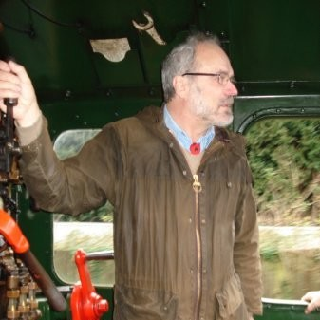​Captain John Hunt is a seasoned Deep Sea Pilot based in Plymouth, England, with extensive experience in maritime navigation and pilotage. As a certificated Master Mariner, he has served as Master on LPG tankers and worked on survey vessels in the oil exploration industry. In his role as a Deep Sea Pilot, Captain Hunt provides expert navigation services to vessels transiting the English Channel and North Sea, ensuring safe passage through some of the world's busiest and most challenging shipping lanes. His deep understanding of maritime operations and commitment to safety make him a respected figure in the maritime community.​ Captain Hunt's career reflects a dedication to maritime excellence, combining hands-on experience with a thorough knowledge of navigational practices.

# Tim Charlesworth

Committee Member

Captain Tim Charlesworth is a distinguished maritime professional who served as Harbour Master and Chief Executive of the Cattewater Harbour Commissioners in Plymouth from 1997 until his retirement in March 2020. With a seafaring career spanning 26 years, including 11 years as Master, he brought extensive experience to his leadership role at the Port of Plymouth. During his 24-year tenure, Captain Charlesworth oversaw significant developments within the harbour, including the commissioning of new vessels, modernization of harbour legislation, and the strengthening of relationships with operators and key stakeholders. Beyond his duties at Cattewater, he contributed to the broader maritime community as treasurer of the South West Regional Ports Association and as a member of the British Ports Association Council. In recognition of his services to UK ports and the maritime industry, Captain Charlesworth was awarded the Merchant Navy Medal for Meritorious Service in 2018.